Foodies Web App

Risk management policy

V1.0

19/2/2023

VERSION HISTORY

Version # | Issued  By | Date | Approved  By | Approval  Date | Reason
1.0 | Nader Abdallah | 22-2-2023 |  |  | Initial Risk Management policy draft

TABLE OF CONTENTS

1.1 Purpose Of The Risk Management Plan ______________________ 4
1.2 Process _______________________________________________ 4
1.3 Risk Identification _________________________________________4
1.4 Risk Analysis____________________________________________ 5
1.4.1 Qualitative Risk Analysis __________________________________ 5
1.4.2 Quantitative Risk Analysis __________________________________ 6
1.5 Risk Response Planning ___________________________________ 6
1.6 Risk Monitoring, Controlling, And Reporting____________________ 7
1.7 risk management plan approval _____________________________ 10
1.8 APPENDIX A: REFERENCES ______________________________ 10
INTRODUCTION

Purpose Of The Risk Management Plan
A risk is an event or condition that, if it occurs, could have a negative effect on a project’s objectives. Risk Management is the process of identifying, assessing, responding to, monitoring, and reporting risks. This Risk Management Plan defines how risks associated with the System project will be identified, analyzed, and managed. It outlines how risk management activities will be performed, recorded, and monitored throughout the lifecycle of the project and provides templates and practices for recording and prioritizing risks.
The Risk Management Plan is created by the project manager in the Planning Phase and is monitored and updated throughout the project.
The intended audience of this document is the project team, project customer and management.
risk management Procedure

Process
The project manager working with the project team and project customer will ensure that risks are actively identified, analyzed, and managed throughout the life of the project. Risks will be identified as early as possible in the project so as to minimize their impact. The steps for accomplishing this are outlined in the following sections. The project manager will serve as the Risk Manager for this project.

Risk Identification
Risk identification will involve the project team, appropriate stakeholders, and will include an evaluation of environmental factors, organizational culture and the project management plan including the project scope. Careful attention will be given to the project deliverables, assumptions, constraints, WBS, cost/effort estimates, and other key project documents.
A Risk Management Log will be generated and updated as needed and will be stored electronically in the project library located at Risk_Management_Log.xls.

Risk Analysis
All risks identified will be assessed to identify the range of possible project outcomes. Qualification will be used to determine which risks are the top risks to pursue and respond to and which risks can be ignored.

Qualitative Risk Analysis
The probability and impact of occurrence for each identified risk will be assessed by the project manager, with input from the project team using the following approach:

Probability
- High
- Medium
- Low

Impact
- High – Risk that has the potential to greatly impact project cost, project schedule or performance
Impact | H
Impact | M
Impact | L
Impact |  | L | M | H
 | Probability

- Medium – Risk that has the potential to slightly impact project cost, project schedule or performance

- Low – Risk that has relatively little impact on cost, schedule or performance
Risks that fall within the RED and YELLOW zones will have risk response planning which may include both a risk mitigation and a risk contingency plan.

Quantitative Risk Analysis
Analysis of risk events that have been prioritized using the qualitative risk analysis process and their affect on project activities will be estimated, a numerical rating applied to each risk based on this analysis, and then documented in this section of the risk management plan.

Risk Response Planning
Each major risk (those falling in the Red & Yellow zones) will be assigned to a project team member for monitoring purposes to ensure that the risk will not “fall through the cracks”.
For each major risk, one of the following approaches will be selected to address it:

- Avoid – eliminate the threat by eliminating the cause

- Mitigate – Identify ways to reduce the probability or the impact of the risk

- Accept – Nothing will be done

- Transfer Make another party responsible for the risk
For each risk that will be mitigated, the project team will identify ways to prevent the risk from occurring or reduce its impact or probability of occurring. This may include prototyping, adding tasks to the project schedule, adding resources, etc.
For each major risk that is to be mitigated or that is accepted, a course of action will be outlined for the event that the risk does materialize in order to minimize its impact.

Risk Monitoring, Controlling, And Reporting
The level of risk on a project will be tracked, monitored and reported throughout the project lifecycle.
All project change requests will be analyzed for their possible impact to the project risks.
Management will be notified of important changes to risk status as a component to the Executive Project Status Report.
Tools And Practices
A Risk Log will be maintained by the project manager and will be reviewed as a standing agenda item for project team meetings.
The figure below shows the template that we have used to cover this section

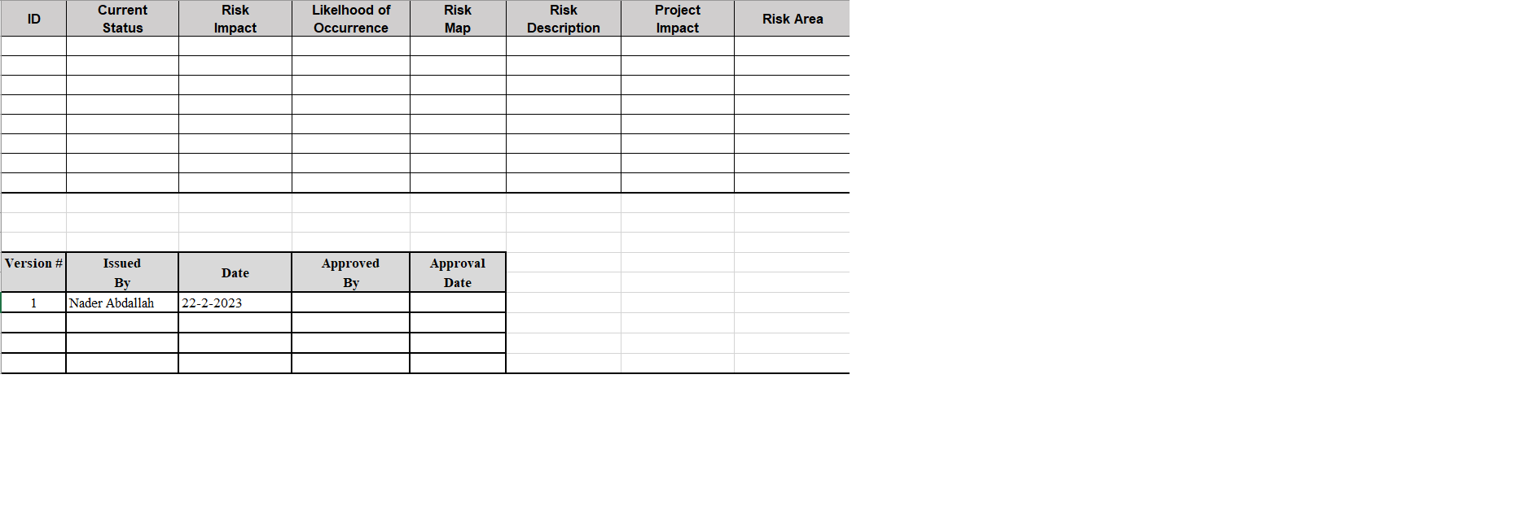

As shown in the above figure, each identified risk will has the following specs:
- ID: A unique ID number used to identify the risk in the risk tracking log.

- Current Status: This column should be populated with the risk's current status.

- Open: The risk is currently open but is not yet an issue.
- Closed: The risk is no longer considered an active project threat and can be closed with or without resolution.

- Risk Impact: This column should be populated with the potential impact of the risk if it did become a project issue. Valid options include the following: High, Medium, Low. These are defined as follows:
- High: Risk that has the potential to greatly impact project cost, project schedule or performance.

- Medium: Risk that has the potential to slightly impact project cost, project schedule or performance.

- Low: Risk that has relatively little impact on cost, schedule or performance.

- Probability of Occurrence: This column should be populated with the estimated probability that the risk will at some point become a project issue.

- Risk Map: This is a calculated field based on the values selected for both Risk Impact and Probability of Occurrence.

- Green: LL (Low Probability, Low Impact), LM (Low Probability, Medium Impact), ML (Medium Probability, Low Impact).

- Yellow: LH (Low Probability, High Impact), MM (Medium Probability, Medium Impact), HL (High Probability, Low Impact).

- Red: MH (Medium Probability, High Impact), HM (High Probability Medium Impact), HH (High Probability, High Impact).

- Risk Description: This column should be populated with a description of the risk.

- Project Impact: This column should be populated with a description of the potential project impact as a result of the risk.

- Risk Area: This column should be populated with the appropriate risk area.

risk management plan approval
The undersigned acknowledge they have reviewed the Risk Management Policy for the project. Changes to this Risk Management Plan will be coordinated with and approved by the undersigned or their designated representatives.
Name | Role | Date
 | Team Leader
 | Customer

APPENDIX A: REFERENCES

The following table summarizes the documents referenced in this document.
Document Name and Version | Description | Location
RISK LOG Document | Contain Probable Risk with risk Impact and Probability of Occurrence

